Asia-China-Coin-Flat Handled Spade Money-Type 1-Arched Foot Spades

State of Liang (Wei) 425-344 BCE, Bronze Flat Handled Arched Foot Spade, 400-300 BCE.

This type has an arched crotch, often like a inverted U. The shoulders can be rounded or angu­lar. Denominations of half, one, or two jin are normally specified. They are associated with the State of , Liang (also known as Wei) which flourished between 425 and 344 BCE, and the State of Han

Flat Handled Spades have lost the hollow handle of the early spades. They nearly all have dis­tinct legs， suggesting that their pattern was influenced by the pointed shoulder Hollow Handled Spades， but had been further stylized for easy handling. They are generally smaller， and some­times have denominations specified in their inscriptions as well as place names. This， together with such little evidence as can be gleaned from the dates of the establishment of some of the mint towns， show that they were a later development. Archaeological evidence dates them to the Warring States period (475-221 BC). Arched Foot spades have an alloy consisting of about 80% copper; for other types the copper content varies between 40% and 70%.

This type has an arched crotch, often like a inverted U. The shoulders can be rounded or angu­lar. Denominations of half, one, or two jin are normally specified. They are associated with the State of Liang (also known as Wei) which flourished between 425 and 344 BCE， and the State of Han.

Example 1. Ān Yì bàn [half] jīn, 安邑半釿, Round Shoulder, Inscription inverted

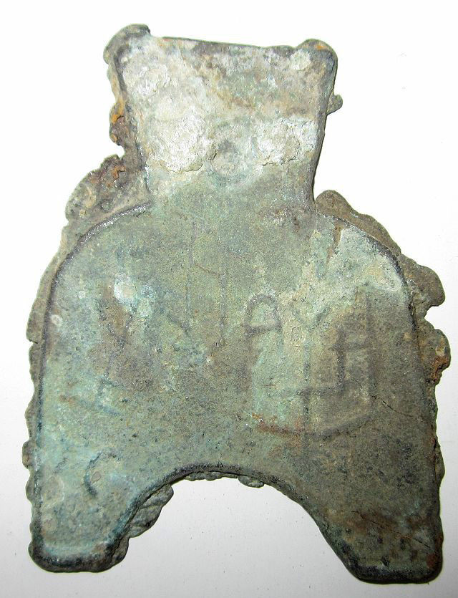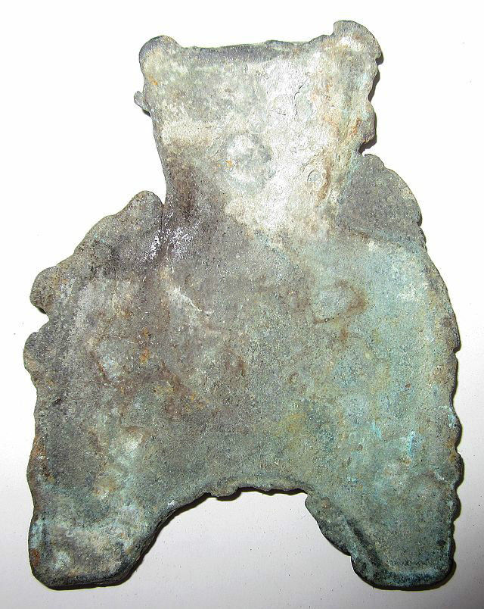

Example 2. Ān Yì Èr [two] Jīn, 安邑二釿, length 4.5CM/1.77Inches, width 3.3CM/1.30Inches.

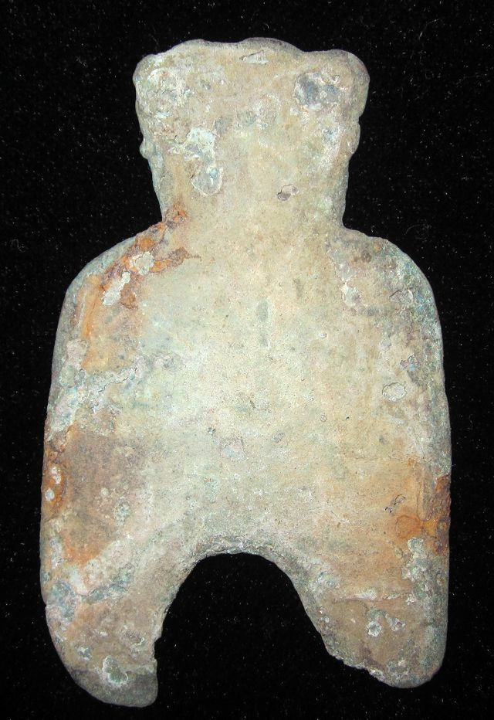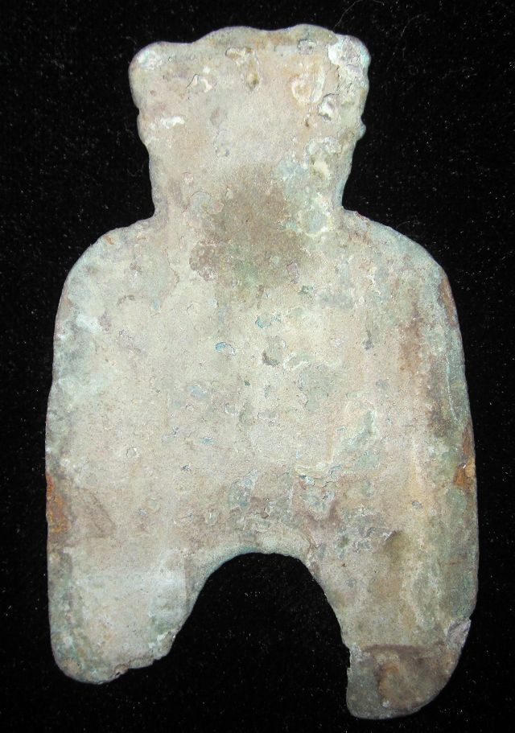

Type1. 弧足布Arched Foot Spade, Ān Yì Èr Jīn安邑二釿, Anyi Two Jin, Length 6.2CM/2.44Inches, Width 3.8CM/1.50Inches

Example 3. 京一釿/甫反一釿桥足布,Yi Yi Jin length, 4.2CM/1.65Inches, width 2.9CM/1.14Inches.

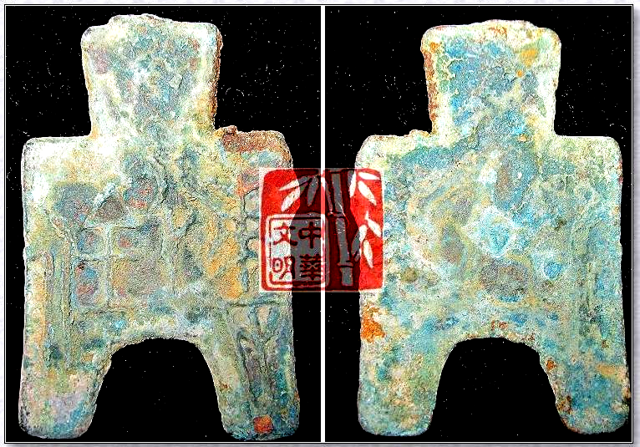

京一釿桥足布."京一釿"also called"甫反一釿"."京"Place of WEI,"一釿"Seals Weight.It was used in the WEI Nation,Warring States Period

Example 4. Liáng èr jīn, qiáo dāng bù, 梁二釿桥裆布length 6.5CM/2.60Inches , width 3.8CM/1.50Inches

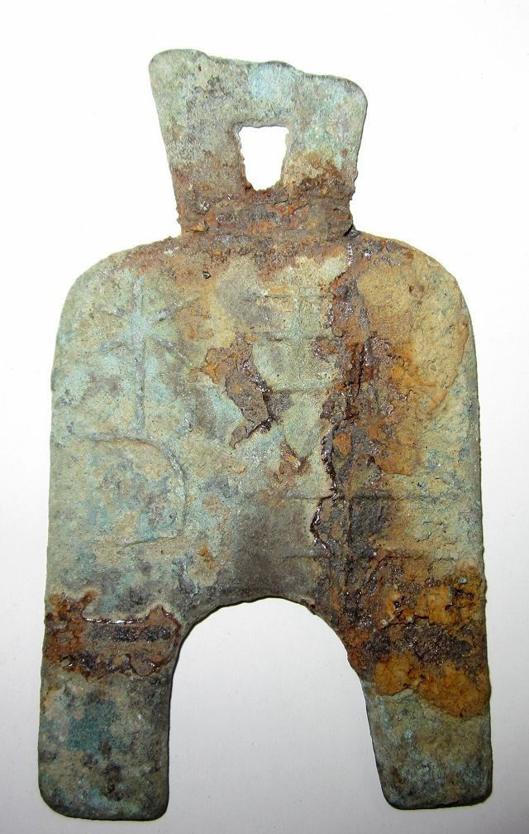 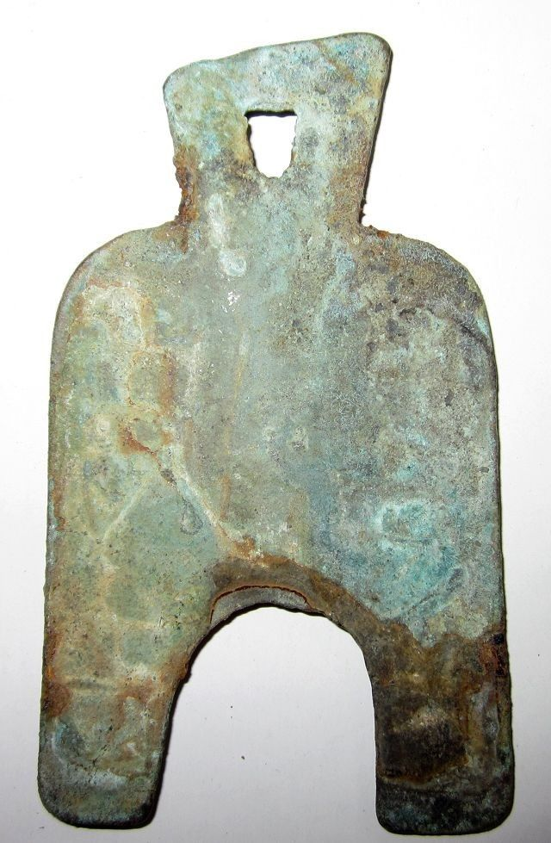

"梁二釿",Liang ErJin Spade-shape Coin.LIANG,Capital of WEi Nation,Now the KaiFeng Town,HeNan Province.JIN,Ancient metals weight,as well as currency.In the WarringStatesPeriod,all kingdoms regarded"JIN"as the basic unit.

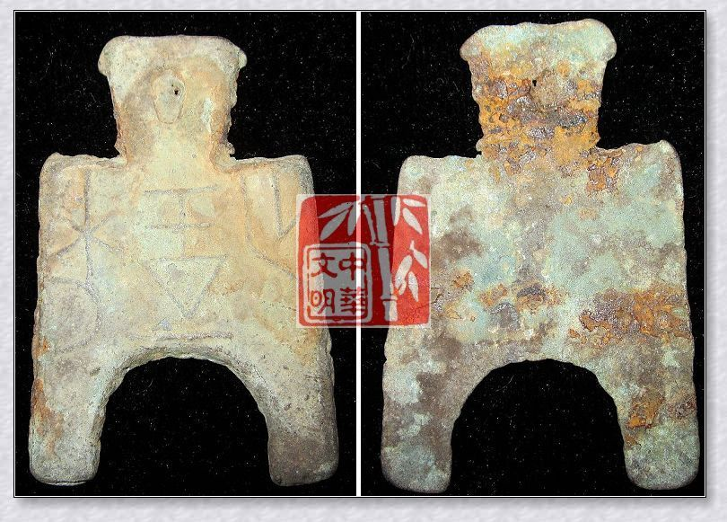

Arched Foot Spade (400-300 BCE), Obv. Liang Yi Jin (Liang one jin), H H 3.22 R 7.

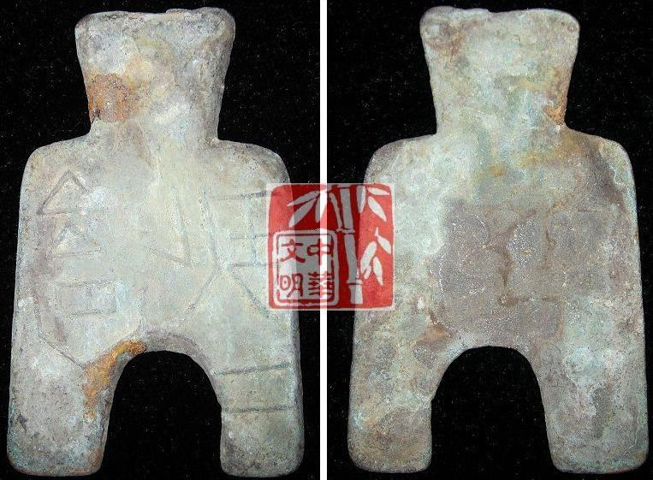

Arched Foot Spade 400-300 BCE H 3.10 R 7, FD 301, S 1.

An Yi Er Jin (In the Warring States period, An Yi in SW Shanxi, was the captial of the State of Liang (Wei).

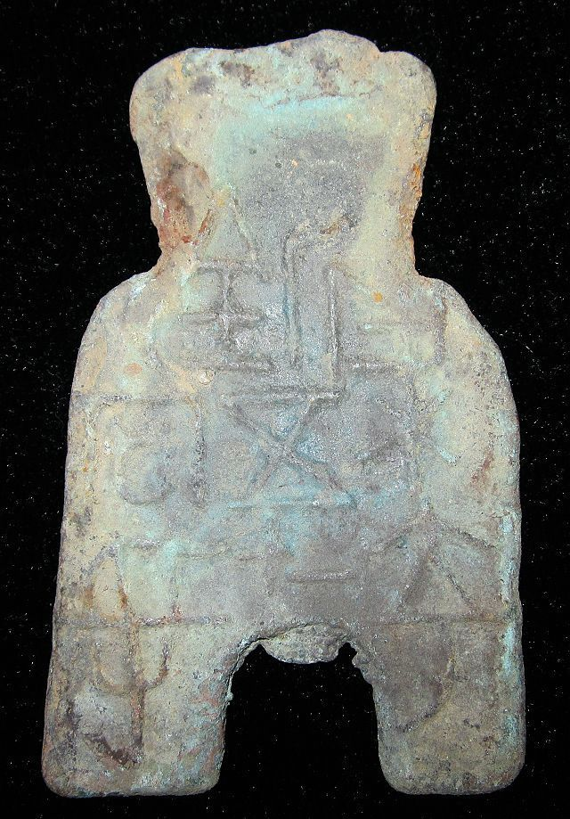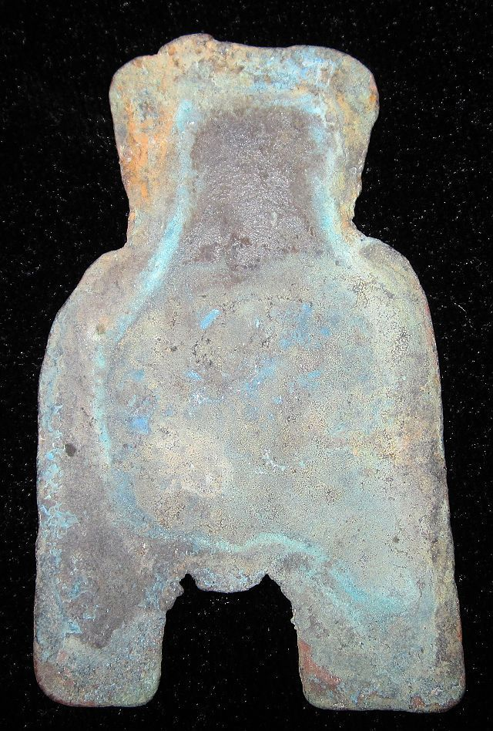

Arched Foot Spade-Laing Dang Lie (400-300 BCE) , Two Jin Liang coin, rev. plain length 5.9CM/2.32Inches, width 3.5CM/1.38Inches, H 3.48 R 7, DCD 217, FD 307.

梁充釿五二十当寽桥裆布."梁",Capital of the WEI Nation,"釿"Seals Weight,"寽"weight.It used in the WEI Nation,middle or late warring sates period.

This collection is a very rare Bronze Spade-shape Coin.

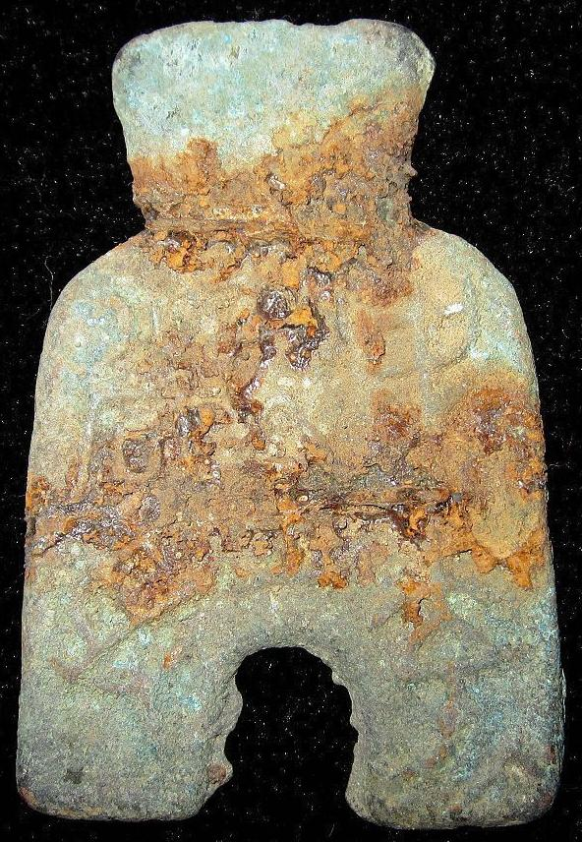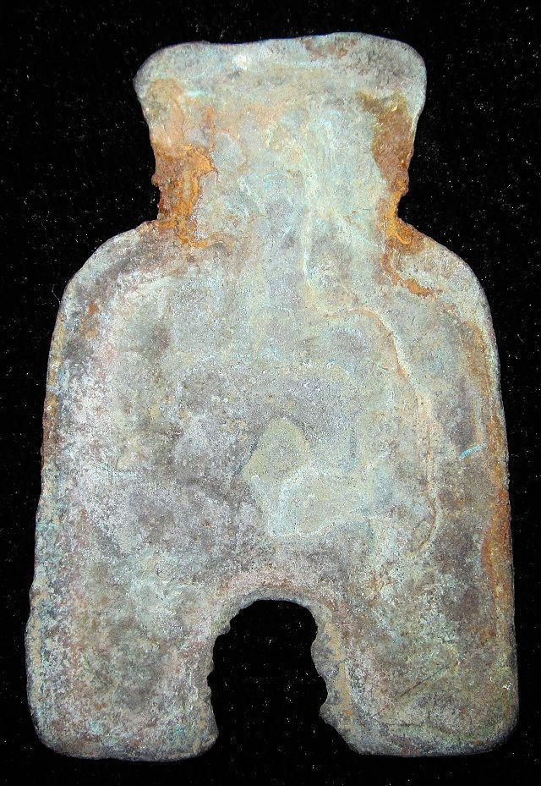

Arched Foot Spade-Laing Dang Lie (400-300 BCE) , New One Jin Liang coin, H 3.47 R 6

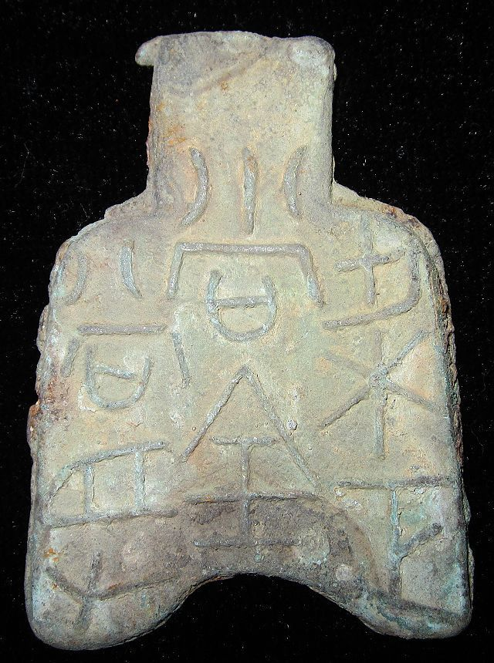

Arched Foot Spade-Laing Dang Lie (400-300 BCE) , Regular One Jun Liang Coin, H 3.44 R 6

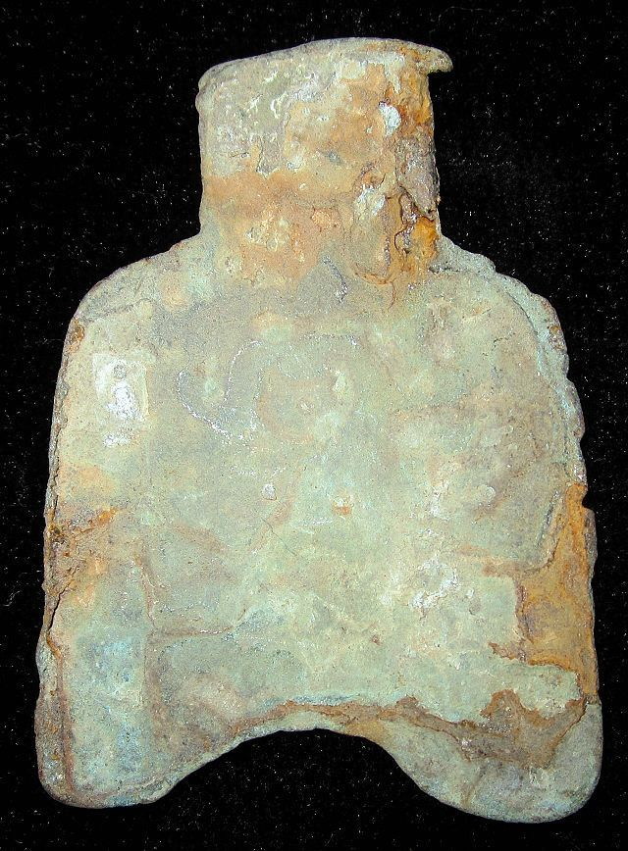

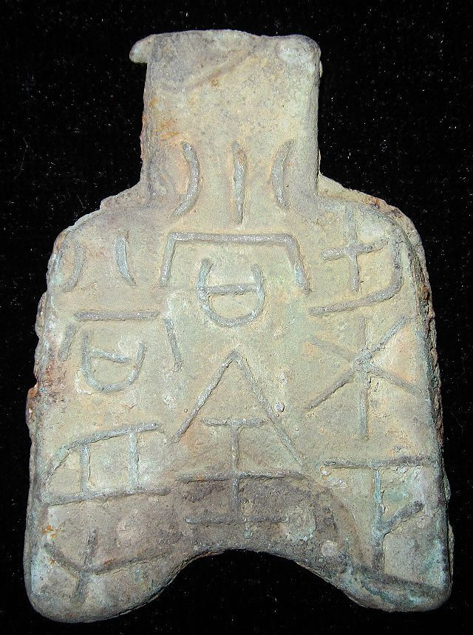

Arched Foot Spade-Laing Dang Lie (400-300 BCE) , 3.8 cm. / 1.50 in., width 2.9 cm. / 1.14 in., H 3.34?

阴晋桥足布."阴晋" which should be a place.It was used in the WEI Nation,middle or late warring sates period.

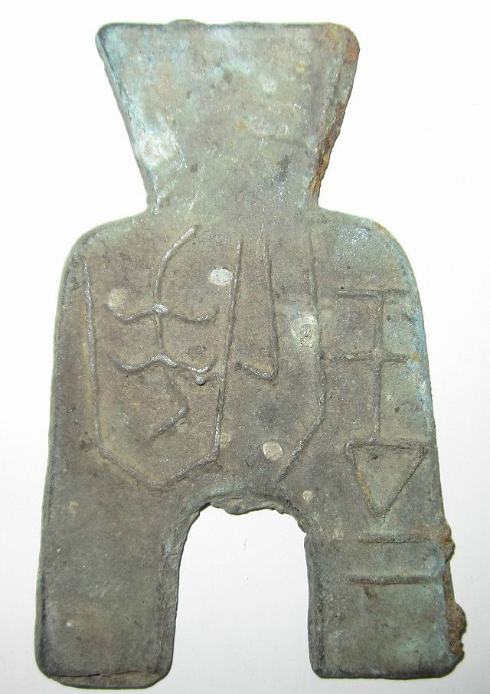

Arched Foot Spade-Laing Dang Lie (400-300 BCE) , H 3.13 R 2

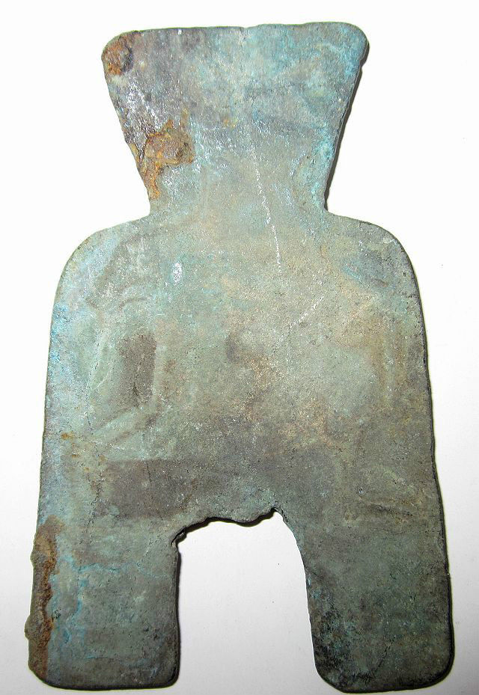

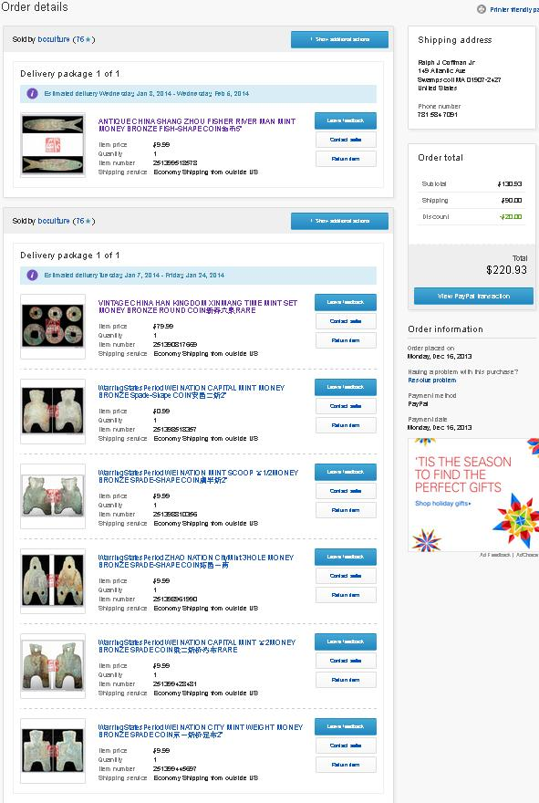

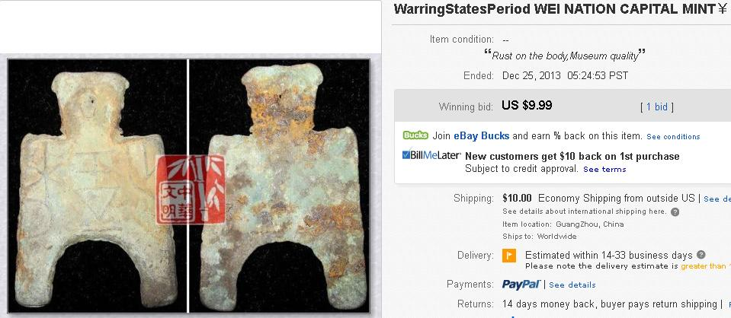

### You won this auction. | [View order details](http://payments.ebay.com/ws/eBayISAPI.dll?ViewPaymentStatus&transid=0&ssPageName=STRK:MESO:VPS&itemId=251406886900)

|  |  |  |
| --- | --- | --- |
| Details about  WarringStatesPeriod WEI NATION CAPITAL MINT ￥1MONEY BRONZE SpadeShape COIN安邑二釿2" [See original listing](http://www.ebay.com/itm/WarringStatesPeriod-WEI-NATION-CAPITAL-MINT-1MONEY-BRONZE-SpadeShape-COIN-2-/251406886900?nma=true&si=5L4Tlo08dyY9pQflhUEb6fWvMTI%253D&orig_cvip=true&rt=nc&_trksid=p2047675.l2557) | | |
| |  |  | | --- | --- | | |  | | --- | |  | | |  |  |
|  |  |
| Item condition:  --not specified  “Rust on the body,Museum quality” |  |
| Ended:  Dec 25, 2013 19:03:58 PST |  |
| Winning bid:  US $9.99  [ [1 bid](http://offer.ebay.com/ws/eBayISAPI.dll?ViewBids&_trksid=p2047675.l2565&rt=nc&item=251406886900) ] |  |
| Shipping:  $10.00 Economy Shipping from outside US |  |
| Item location:  GuangZhou, China |  |
| Seller:  [bcculture](http://myworld.ebay.com/bcculture?_trksid=p2047675.l2559) ([79](http://feedback.ebay.com/ws/eBayISAPI.dll?ViewFeedback&userid=bcculture&iid=251406886900&ssPageName=VIP:feedback&ftab=FeedbackAsSeller&rt=nc&_trksid=p2047675.l2560) )  |  [Seller's other items](http://www.ebay.com/sch/bcculture/m.html?item=251406886900&rt=nc&_trksid=p2047675.l2562) |  |

# WARRING STATES PERIOD WEI CAPITAL MINT CURRENCY MONEY BRONZE SPADE COIN梁充釿五二十当寽

### Seller information

|  |  |
| --- | --- |
|  |  |

[bcculture](http://myworld.ebay.com/bcculture?_trksid=p2047675.l2559) ([79](http://feedback.ebay.com/ws/eBayISAPI.dll?ViewFeedback&userid=bcculture&iid=251407573977&ssPageName=VIP:feedback&ftab=FeedbackAsSeller&rt=nc&_trksid=p2047675.l2560) )

100% Positive feedback

[Follow this seller](http://www.ebay.com/itm/WARRING-STATES-PERIOD-WEI-CAPITAL-MINT-CURRENCY-MONEY-BRONZE-SPADE-COIN-/251407573977?nma=true&si=5L4Tlo08dyY9pQflhUEb6fWvMTI%253D&orig_cvip=true&rt=nc&_trksid=p2047675.l2557)

[See other items](http://www.ebay.com/sch/bcculture/m.html?item=251407573977&nma=true&rt=nc&si=5L4Tlo08dyY9pQflhUEb6fWvMTI%253D&orig_cvip=true&_trksid=p2047675.l2562)

Visit store:

[bcculture](http://stores.ebay.com/bcculture?_trksid=p2047675.l2563)

Top of Form

## Item Information

Item condition:

--not specified

“Rust on the body,Museum quality”

Ended:

Dec 26, 2013 17:17:27 PST

Winning bid:

US $9.99

[ [1 bid](http://offer.ebay.com/ws/eBayISAPI.dll?ViewBids&_trksid=p2047675.l2565&rt=nc&item=251407573977) ]

|  |  |  |  |
| --- | --- | --- | --- |
|  | Join **eBay Bucks** and earn **%** back on this item. [See conditionsfor eBay Bucks - opens in a new window or tab](http://pages.ebay.com/rewards/terms.html?ssPageName=STRK:VI:LNLK:TCS) | |  |
|  | | New customers get $10 back on 1st purchase Subject to credit approval.[See terms](https://apply.billmelater.com/apply?guid=1SJ8TEIO&assetId=NBRVI1213) | |

Shipping:

$10.00 Economy Shipping from outside US | [See details](http://www.ebay.com/itm/WARRING-STATES-PERIOD-WEI-CAPITAL-MINT-CURRENCY-MONEY-BRONZE-SPADE-COIN-/251407573977?nma=true&si=5L4Tlo08dyY9pQflhUEb6fWvMTI%253D&orig_cvip=true&rt=nc&_trksid=p2047675.l2557" \l "shpCntId)

See details about international shipping here.

Item location:

GuangZhou, China

Ships to:

Worldwide

Delivery:

Estimated within 14-33 business days

Please note the delivery estimate is greater than 13 business days.

Payments:

 | [See details](http://www.ebay.com/itm/WARRING-STATES-PERIOD-WEI-CAPITAL-MINT-CURRENCY-MONEY-BRONZE-SPADE-COIN-/251407573977?nma=true&si=5L4Tlo08dyY9pQflhUEb6fWvMTI%253D&orig_cvip=true&rt=nc&_trksid=p2047675.l2557" \l "payCntId)

Bottom of Form